# CS 255 System Design Document Template

This template lays out all the different sections that you need to complete for Project Two. Each section has guidance to prompt your thinking. You will need to continually reference the interview transcript as you work to make sure that you are addressing your client’s needs. There is no required length for the final document. Instead the goal is to complete each section based on what your client’s needs are. Remove this note when you are finished, and replace all bracketed text with the relevant information.

## UML Diagrams

### UML Use Case Diagram

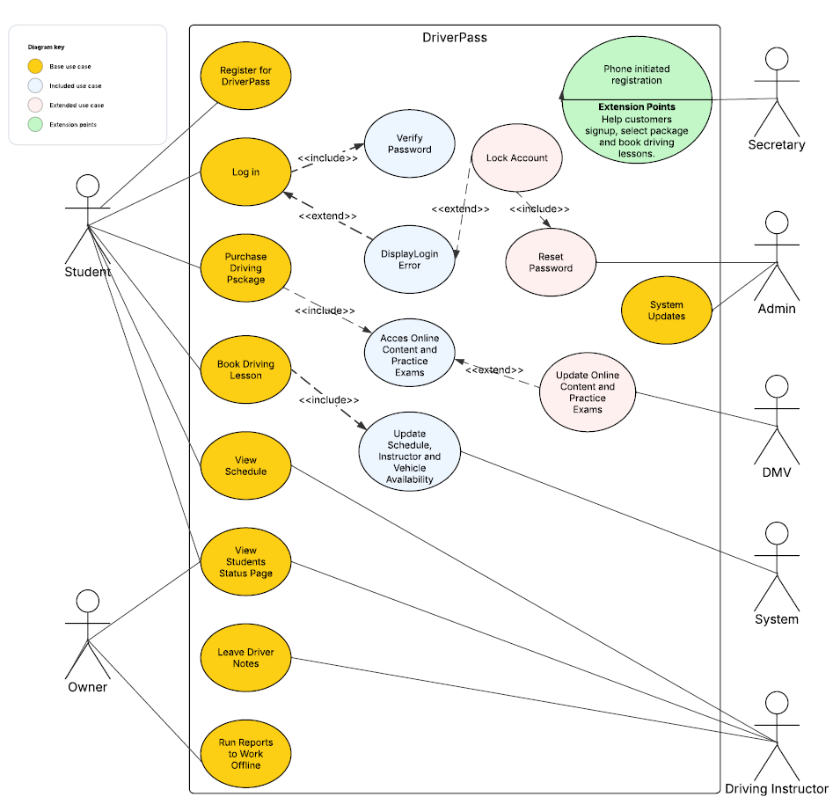

UML Activity Diagrams

**DriverPass Login/Registration**

**Driving Package Purchase and Selection**

### UML Sequence Diagram

**DriverPass Registration**

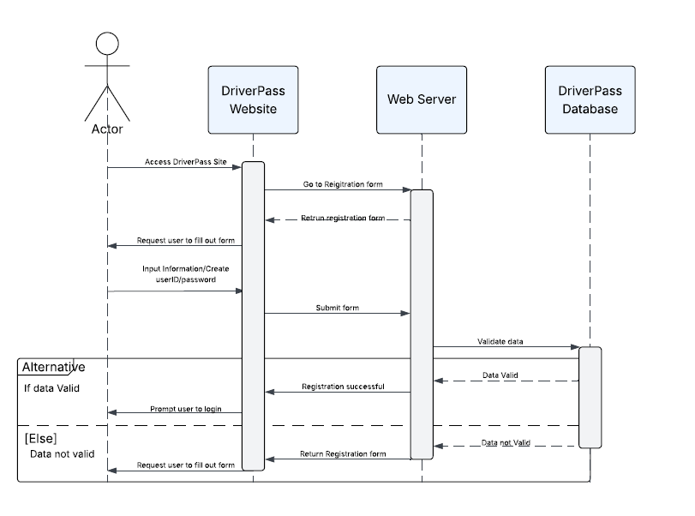

### UML Class Diagram

**Driver Pass IML Class Diagram**

## Technical Requirements

Some technical requirements for the system would be as follows.

1. The application would be hosted on a cloud-based server as the client has made it clear they would prefer the provider to handle backups and security so they can focus on their business.
2. Additionally adequate data storage would need to be purchased and allocated from the cloud provider.
3. The system would also require a database to store all relevant information. I would suggest MYSQL due to its user-friendly environment, scalability and performance.
4. The web-based application would be written in either JavaScript or Python due to their commonality which will improve maintainability.
5. The development of the project will be done in a Linux environment, due to its flexibility, using Visual Studio Code as an IDE and GIT for version control.
6. The application must be compatible with Windows, MacOS, IOS and Android to maximize the potential customer base.
7. Firewalls, strong password suggestions and multifactor authentication would be used for increased security.